PRESS RELEASE FROM HITCHIN HISTORICAL SOCIETY
Contacts: Richard Whitmore (Hitchin 433261) or Sam Hallas (Hitchin 623174)

OLD HITCHIN ON FILM Volume Two

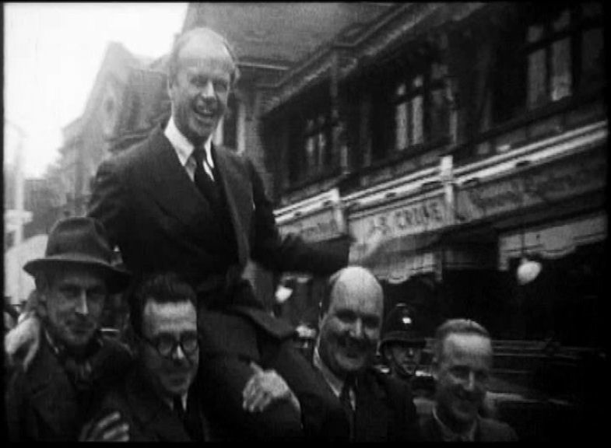

Here are just two images from Hitchin Historical Society’s latest fascinating DVD ‘Old Hitchin on Film’ which goes on sale to the public in early December. The first was taken in 1929 when the town was visited by world famous aviator Sir Alan Cobham (centre of the group) who landed on a field at Foster’s Farm by the Bedford Road at Ickleford during a nationwide tour to promote air travel. After giving pleasure flights to local councillors, he later spoke at a dinner in the Hermitage Halls but failed to persuade the town to build a civil airport.
In October 1951, Hitchin’s new Tory M P, Nigel Fisher MC, was carried shoulder high down Brand Street after winning the seat in the General Election. Sir Nigel, as he became, represented Hitchin in parliament until 1955, when he was moved to the ‘safe’ Tory seat of Surbiton in Surrey. He retired in 1983 after holding several junior ministerial posts during a long parliamentary career.
The DVD also features ‘Sleepy Hollow’ a long-forgotten colour slide tour of Hitchin compiled by the minister of Tilehouse Street Baptist Church, the Reverend Robert Tebbutt, in the 1970s. The slides, complete with Mr Tebbutt’s original commentary, were found recently by his daughter, having been stored away and forgotten for more than 40 years.
In all there are 16 re-discovered local films on the DVD. They include the Graveley Air Disaster of 1912, parachute testing at RAF Henlow in the 1920s, the 1969 Hitchin and Letchworth Carnival, the West Hill Jubilee street party of 1977 and the Queen’s visit to Hitchin during her 2012 Diamond Jubilee celebrations.
Hitchin Historical Society will launch volume two of ‘Old Hitchin on Film,’ at the Queen Mother Theatre in Walsworth Road on Saturday December 5th at 2pm, when extracts from the DVD will be shown. They will also be on sale at Hitchin Initiative in Churchyard and Eric T Moore Books, 24 Bridge Street, Hitchin.
-o0o-

